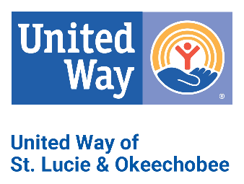

United Way of St. Lucie County’s Practice Concerning Donor Privacy

United Way of St. Lucie & Okeechobee (UWSLO) respects the privacy of donors and safeguards the confidentiality of information that the donor would reasonably expect to be private. Information learned by any representative of UWSLO about a donor shall be held in strict confidence.

Donors who reach special recognition levels may be acknowledged and published in various UWSLO publications and campaign materials, unless the donor requests to remain anonymous by indicating their wishes on the United Way pledge card, or by contacting UWSLO CEO or staff. At the request of the donor, information about the donor, the amount of gift or any other information concerning their donations will not be made public. UWSLO will not sell, rent or share its mailing lists of donors or prospective donors.

Donors may feel free to contact United Way CEO or campaign staff with any questions about this Donor Privacy Policy, or to review or change their information. (772).464.5300

